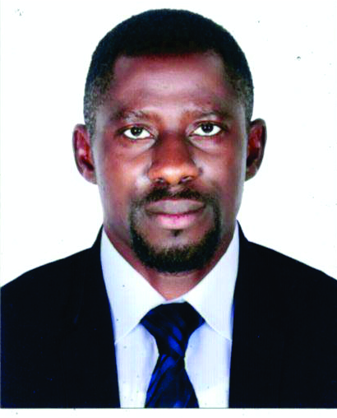

**ONIAKHENA STEPHEN**



Oniakhenastephen40@gmail.com

09130827811



No: 15 Lawrence Street Off Abanise, Agodo Egbe, Ikotun, Lagos

**CAREER OBJECTIVES:**

To practice the knowledge acquired in a dynamic organization that is purpose driven and result oriented, where individual initiative and idea are valued for the purpose of adding value.

**PERSONAL DETAILS:**

* Date Of Birth: 1st September 1985
* Sex: Male
* Marital Status Married
* Local Government Area Etsako West
* Sate Of Origin Edo Sate
* Nationality Nigerian
* Religion Christianity
* Language English, Etsako

**PERSONAL PROFILE:**

* Ambitious, high self-esteem, hardworking and confident.
* Committed, disciplined, tact with a strong driven to succeed
* Ability to adapt with new systems and acquire new skills and knowledge within a short period of time
* Integrity and accountability
* Positive mindset and very good communication skills and ability to cope under pressure

**INSTITUTION ATTENDED AND QUALIFICATIONS WITH DATE:**

* Security cadre training (Dubai) 2021
* Computer network service (Malaysia) 2019
* Auchi Polytechnic Auchi, Edo State

Higher National Diploma (HND) Business Administration & Mgt. 2007-2009

* Auchi Polytechnic Auchi, Edo State

National Diploma (ND) Business Administration & Mgt. 2003-2006

* Diligence Secondary School, Jattu Edo State

Senior Secondary School Certificate 1996-2002

* Inigbi Primary School, Elele Edo State

Junior Secondary School Certificate 1989-1996

**WORK EXPERIENCE:**

* Bondi Digital Venture October 2022-August 2023

No 30 Agoowu Street Shomolu Lagos

**Job Position:** Procurement Manager

**RESPONSIBILITIES:**

* Purchase Supply Of products/Materials
* Track And record Orders
* Receive Orders and document arrivals
* Manage supply base
* Determine the lowest cost Of products/Materials
* Source and Interview Vendors; Negotiate Contract and Cost
* Tawal Maldina Security Service Company, (Dubai) 2021-2022

**Job Position:** Security personnel

**RESPONSIBILITIES:**

* Secure premises and personnel, monitoring surveillance equipment
* Complete report by recording observations, information occurrences and obtaining signatures.
* Maintain environment by monitoring the building and equipment controls
* Ensure operation of equipment by completing preventive maintenance requirement.
* Troubleshooting malfunctions, calling for repairs evaluating new equipment and techniques
* Aquaplus Water Company (Dubai) 2019-2021

**Job Position:** Sales Representative

**RESPONSIBILITIES:**

* Sale products and services to prospective customers
* Maintain Business relationship to ensure future sales
* Engage with the customer about the product
* Sale the product and give account to the company at the end of the day
* And any other duties assigned to me by the management.
* Sunway Pyramid Hotel, (Malaysia) 2016-2018

**Job Position:** Steward

**RESPONSIBILITIES:**

* Welcoming guests
* Ensuring guest satisfaction
* Listening to guest requirement and communicate to the person concerned
* Taking table Orders
* Integrated Data Service Limited, Edo/Delta 2011-2013

**Job Position:** Assessor

**RESPONSIBILITIES:**

* To access the level of damage made by the company to the community our prospect cut across
* By knowing the level of damage for a compensation to be made to individuals and communities
* After company approval, they will release fund to pay them
* National Youth Service Corps (NYSC) March 2010-Feburary 2011

**Job Position:** Teacher

**RESPONSIBILITIES:**

* Teaching Government and Business Studies
* And any other assignment assigned to me by the management

**INFORMATION TECHNOLOGY SKILLS:**

* Proficient in Microsoft Word and Excel

**HUBBIES:**

* Reading
* Travelling
* Sport

**REFEREES:**

Available On Request